Problem Statement 2: Pricing, Promotions and Margin – Framing Note
Business Analyst, Global Retail Analytics | For: Head of Merchandising | Tool: SQL (MySQL)
Evidence base: 3,340,935 transaction lines from 35 stores, 1 Jan 2023 – 18 Mar 2025, joined to the markdown calendar (discounts). Money in USD (1 EUR = 1.08, 1 GBP = 1.27, 1 CNY = 0.14); production cost is in EUR and converted at 1.08. 25 products carry a cost about 100× too high and are divided by 100. Returns are netted out. Figures are a first look; Part B tests them.
Situation. Zara sells at full price most of the year and marks down only in its Winter and Summer Sales. In 2024 the US and UK also ran Zara's first Black Friday (29 Nov – 2 Dec, 30% off) and started the Winter Sale on 20 Dec instead of 26 Dec. Complication. 19.6% of sale lines are marked down but bring only 13.4% of net sales. Gross margin is 60.6% at full price, 27.2% at 40–50% off and −40.8% at 70% off. In the three weeks before Christmas 2024, US/UK full-price sales fell 14.4% against 2023 while the other countries grew 2.8%. Question. Are our promotions creating or destroying value, and which depth, timing and categories should change?
Problem statement. The Head of Merchandising is facing markdowns of unknown value while trying to protect gross margin, which results in discounts that may only lower the price of sales that would have happened anyway. How might we help Merchandising see, for every sale phase, whether it earned its margin, so that depth, timing and categories are chosen on evidence?

1. Issue tree
A promotion creates value only if it wins volume that would not have come anyway, at a margin still worth having, without training customers to wait, on the right products at the right time.
Branch | Sub-questions | Measure in Part B | First look
Volume gained | Do sale phases sell more than the two weeks before? Which phases add most? | Units and net sales per phase vs the 2 weeks before | To be measured
Margin given up | What does each depth cost? At which depth does a sale lose money? | Gross margin % by depth band (CASE) | Full price 60.6%; 30% 43.4%; 40–50% 27.2%; 70% −40.8%
Customer behaviour | Do customers wait for the sale, or buy earlier at a lower price? Do they return more? | Pre-Christmas full-price sales 2024 vs 2023; return rate by price type | US/UK −14.4% vs others +2.8%; returns 10.6% of units at full price vs 6.6% on markdown
Category and timing | Which collections go into the sale too often, and which never do? | Share of each sub-category's units sold on markdown | Coats and jackets 29.1%, knitwear 28.5%; perfumes 0%, jeans 14.6%

2. Systems thinking: how discounts feed on themselves
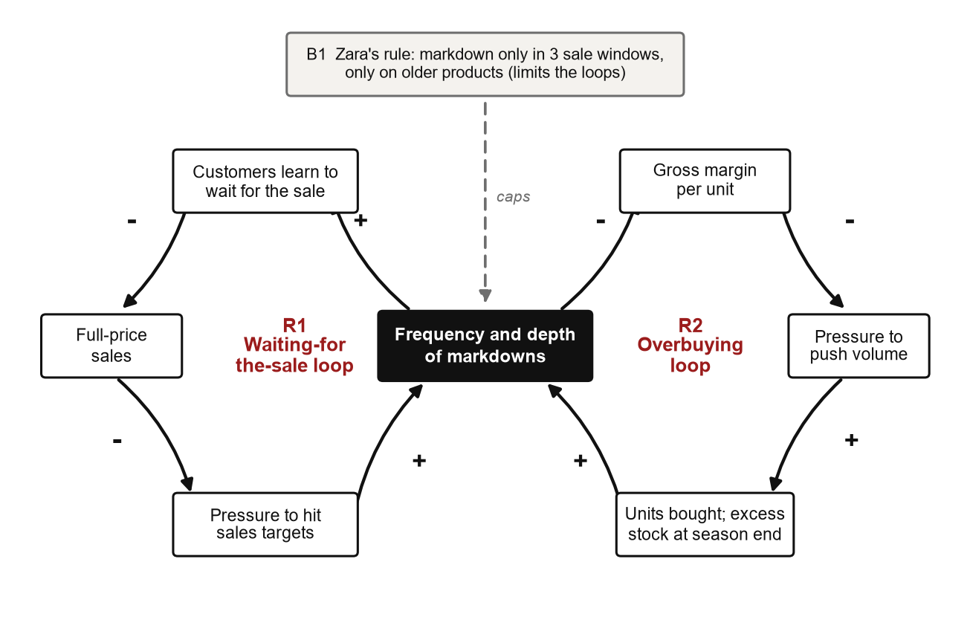
Causal loop. + = same direction; − = opposite direction; R = reinforcing loop; B = balancing loop.
- R1, waiting for the sale (the reinforcing loop). More frequent, deeper discounts teach customers to wait. Full-price sales fall, pressure to hit targets rises, and the easy answer is another markdown. Each sale makes the next one more likely.
- R2, overbuying. Deep markdowns cut margin per unit, so the push for volume grows; buying more leaves more stock to clear at a deeper discount.
- B1, the brake. Fixed sale windows and markdowns only on older stock should hold full-price sales up. The US/UK drop before Christmas 2024 is the first sign the brake may be slipping.
- Iceberg. Event: a margin dip in January. Pattern: it repeats every sale season. Structure: sales targets and the sale calendar. Mental model: "a markdown is the safest way to hit the number". Leverage point: the maximum depth per category, not the number of sale days.

3. Outcome mapping
Impact (business goal): profitable growth. Outputs are what Merchandising controls; outcomes are behaviour changes in the boundary partners whose decisions drive margin.
Outcome (behaviour change) | Boundary partner | Outputs that drive it | Measure in SQL and baseline
Higher gross margin % | Merchandisers set shallower maximum depths | Depth cap per category; fewer 70% phases | Gross margin % by band: 56.5% overall
More sales at full price | Customers buy before the sale instead of waiting | Fewer or later sale phases; Black Friday decision | Full-price share of net sales: 86.6%
Fewer units forced into the sale | Buyers order less of collections that end up discounted | Buying quantities for coats, jackets, knitwear | Units sold on markdown: 19.6%
Fewer returns | Product teams fix items and sizes that come back most | Size and fit fixes on outlier products | Units returned ÷ sold: 9.8%

Progress markers. Expect to see: depth decided per category before each season. Like to see: no 70% phase for categories that lose money at 50%. Love to see: full-price share rising while total margin grows.

4. Requirements: Promotion Performance Report (short BRD)
Section | Content
Business requirement (why) | Give Merchandising a repeatable view of whether each promotion earns its margin. Success: any phase and country can be judged without a new analysis.
Scope | In: Winter Sales 2022-23 to 2024-25, Summer Sales 2023 and 2024, Black Friday 2024; seven countries; Woman, Man, Kids; units, net sales, margin in USD; returns; the period before each phase. Out: customer-level analysis (Problem 3), stock levels (not in the data), price elasticity, competitor prices.
Data sources | transactions, products (with corrected costs), discounts (markdown calendar), stores (country), and an exchange-rate table built in SQL.
Business rules | 1. Money from Line Total, never Invoice Total (4,200 invoices disagree with their lines). 2. Net sales = sales + returns; returned units count as negative. 3. Gross margin = net sales − cost × net units, cost × 1.08. 4. Costs above 200 EUR are divided by 100 (25 products). 5. A markdown line has Discount > 0 and joins the calendar on date range, category, sub-category and country (blank = all seven). 6. "Before" = the two weeks before a sale starts; 2025 is compared only with the same dates in 2024.
Functional requirements (what), MoSCoW | Must: the report shall show margin % by depth band and compare any phase with the period before. Must: a stored procedure promo_report shall take start date, end date and country. Should: results by category and sub-category. Could: a monthly trend with LAG().

Story | As a … I want … so that … | Acceptance criteria (Given / When / Then)
PROMO-1 | As the Head of Merchandising, I want gross margin % by markdown-depth band, so that I can see at which depth a sale starts losing money. | Given all sale lines, when I run the report, then each band (full price, 30%, 40–50%, 60–70%) shows its share of lines, net sales and margin %, and the shares add up to 100%.
PROMO-2 | As a merchandiser, I want each sale phase compared with the two weeks before it, so that I know whether the phase was worth its margin. | Given a phase and a country, when I run the query, then units, net sales and margin show for both periods with the % change; Black Friday applies to the US and UK only.
PROMO-3 | As a regional manager, I want to run promo_report with my dates and country, so that I can compare my promotion with the period before. | Given a start date, end date and country, when I call the procedure, then both periods return in USD; an end date before the start returns a clear error.

5. Hypotheses for Part B
# | We believe that… because… | We will know it is true when… | Test in SQL
H1 | Kids loses money at a shallower depth than Woman and Man, because its margin starts lower (48.3% vs 57.8% and 56.0%) | Kids margin turns negative at a lower depth band | Margin % by category × depth band
H2 | Four sub-categories (coats and jackets, knitwear, kids shoes, girls) hold most markdown units, because they are overbought | They account for most markdown units | Markdown units by sub-category
H3 | 30% phases earn their margin, but the 70% phase loses more margin than it adds in volume | 70% phase margin is below the two weeks before | Phase vs pre-period comparison
H4 | Black Friday and the early sale moved US/UK purchases earlier at a lower price instead of adding sales | US/UK total Nov–Dec sales grew no faster than other countries | Nov–Dec 2024 vs 2023 by country group
H5 | A few products return far more than their sub-category, pointing to size or quality faults | Some products exceed their sub-category rate by a wide margin | Product vs sub-category return rate
H6 | The data fixes matter: Invoice Total or uncorrected costs would move margin by over 0.5 points | Margin changes by more than 0.5 points without the fixes | Totals with and without fixes

Assumptions and limits
- No stock levels in the data, so "overbought" is inferred from the share of units sold on markdown.
- Other checks: 13,363 lines with no size, 6,681 with no colour, 1,452 lines served by staff from another store, 36 products never sold; none changes the margin logic.
- Only the US and UK ran Black Friday, so the other five countries are a comparison group, not a true control. The data is simulated for teaching.

